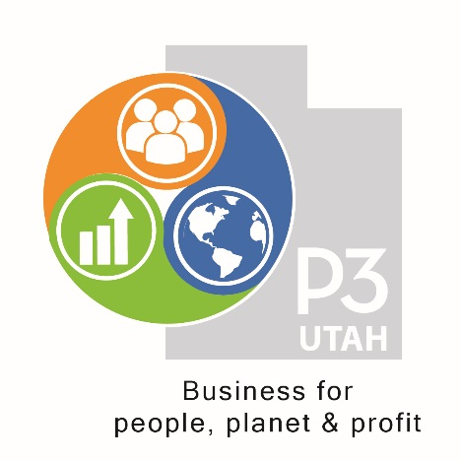
The P3 Utah Pledge
August 16, 2019

I am P3
Business for people, planet and profit: the 3 ps
Business that makes a better, more sustainable world
When I go to work, I want to know, that I am making a better world
Inside the workplace and outside in the community
Socially and environmentally, every day
When I make a purchase, I want to know, that I am making a better world
Every hour of work and every dollar of spending, should make a better world
Business for people, planet and profit: the 3 ps.
Join me in making a better world through business
Be P3

Permission is granted to use this information when accompanied by attribution to P3 Utah 2019

