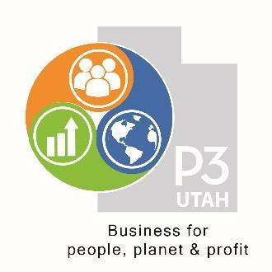
P3 Utah Sustainable Business 3 Level Certification Program
The P3 Utah Sustainability Matrix is to be used as a management tool in order to help the implementation of the principles of the triple bottom line in businesses of any size. It is not meant to be an in depth evaluation of a company’s impact or sustainability plan, but rather a simple measure of how an organization is using the triple bottom line in its day-to-day operations and decisions.
Through an online survey, a set from six to 30 employees will fill out a questionnaire and answer questions based on how they view that management cares for the triple bottom line. At least one member of the company in a managerial role will fill out a different form that states and discusses more specific metrics that management uses to measure and benchmark their triple bottom line. Finally, P3 Utah will also do an analysis of what customers have said about the business online through Google, Facebook, Amazon, and other relevant rating sites. Based on the answers to these questions and analysis, the business will receive a score from 1-9. Later, an official representative of P3 will do an in person evaluation to verify the score.
With this score, a business can evaluate its own efforts and where it could improve. It also can compare itself to other businesses across all sectors. Having a P3 score is also a means whereby a consumer can make an informed purchasing decision. For instance, according to the 2018 Cone/Porter Novelli Purpose Study, “88% would buy a product from a Purpose-driven company and 66% would switch from a product they typically buy to a new product from a Purpose-driven company”(https://engageforgood.com/stats/). The P3 score is a resource for businesses and consumers in Utah to decipher who is actually seeking to be a Purpose-driven organization.
Through time, regular check-ups and testing will help maintain forward progress towards helping management become more effective triple bottom line advocates. Through the years as the business seeks to effectively accomplish their impact goals in each area of the matrix, their profitability as a business will also grow because they are improving in areas that naturally lead to increased revenues and decreased costs.

Level 1: Bronze (Scale 1-3)
Organization needs to:
- Have official written statement/policy as evidence of adopting the triple bottom line in their business strategy.
- Designate a position and group of individuals responsible for implementing impact plan.
- Adopt a method of reporting and being accountable for net triple bottom line impact with stakeholders.
- Use Sustainability Matrix to check for “low hanging fruit” and simple sustainable practices to adopt (LED light bulbs, volunteer day, etc.)
- Have goals for improvement in each of the areas of the Matrix.
- Publish content on website and social media pages about triple bottom line objectives.

Level 2: Silver (Scale 4-6) (

Organization needs to:

- Provide evidence of ongoing management of ability to reach and adjust goals related to cells of Matrix.
- Collect enough data about operations in comparison to industry benchmarks to quantify progress.
- Show evidence of significant progress towards long term net positive impact goals (25-49%).
- Continue to report on process and outcomes to stakeholders with increasing sophistication.
- Begin to achieve industry/product/resource/process certifications (at least 20% of those available in the given industry).
Level 3: Gold (Scale 7-9) (70-90 points)
Organization needs to:
- Qualify for B Corp certification.
- Attain all applicable industry certifications.
- Provide evidence of ongoing management of ability to reach and adjust goals related to cells of Matrix.
- Show evidence of substantial progress towards long term net positive impact goals (50-100%).
- Continue to report on process and outcomes to stakeholders with increasing sophistication.

